Lab Report

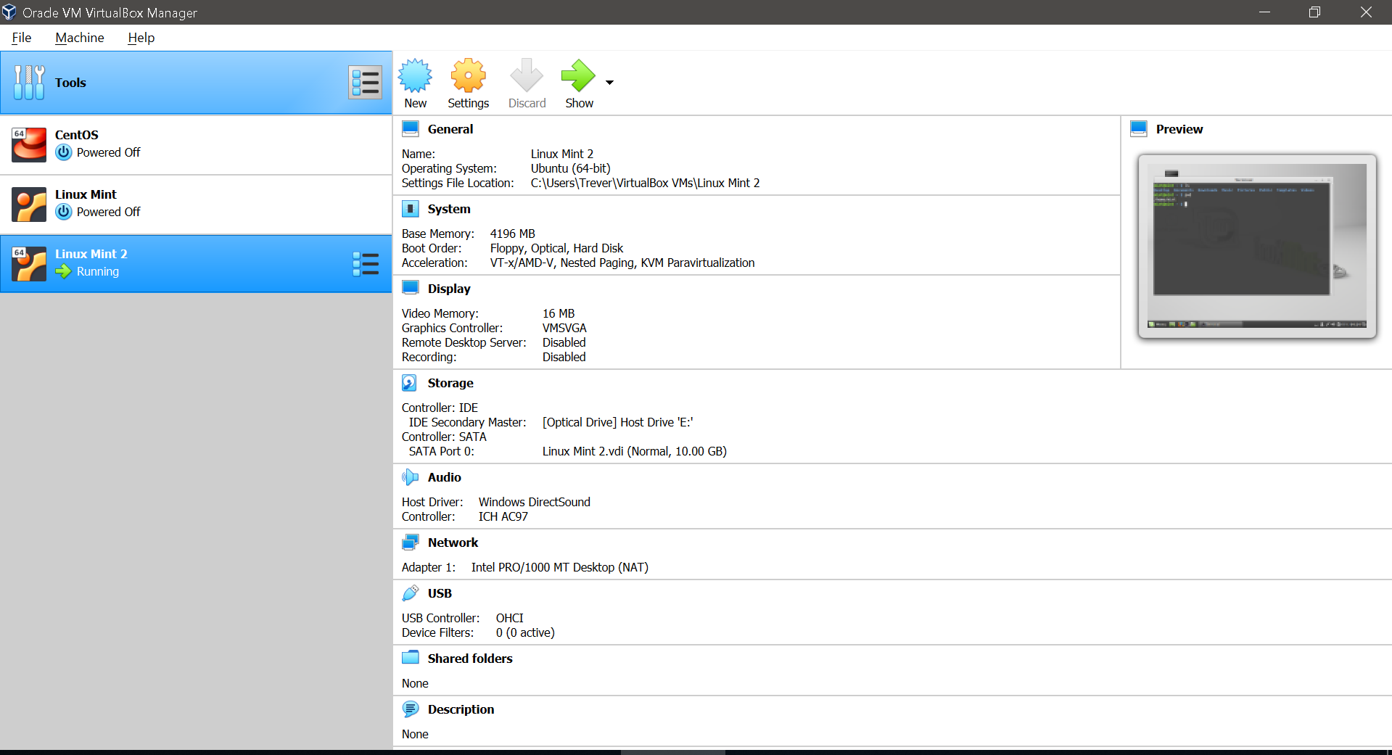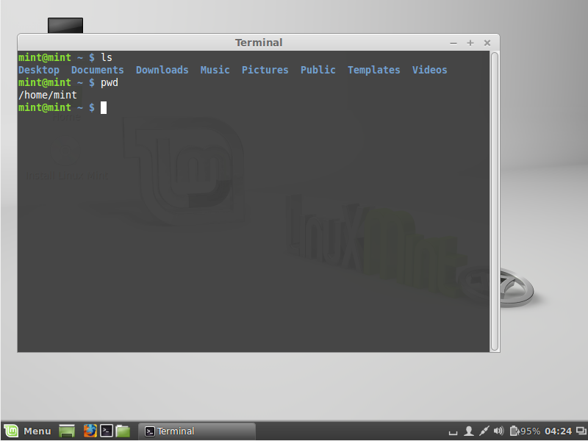

Downloaded Virtual Box because I was unable to locate email regarding VMWare installation.

Above you will see the same information that would be displayed in VMWare.

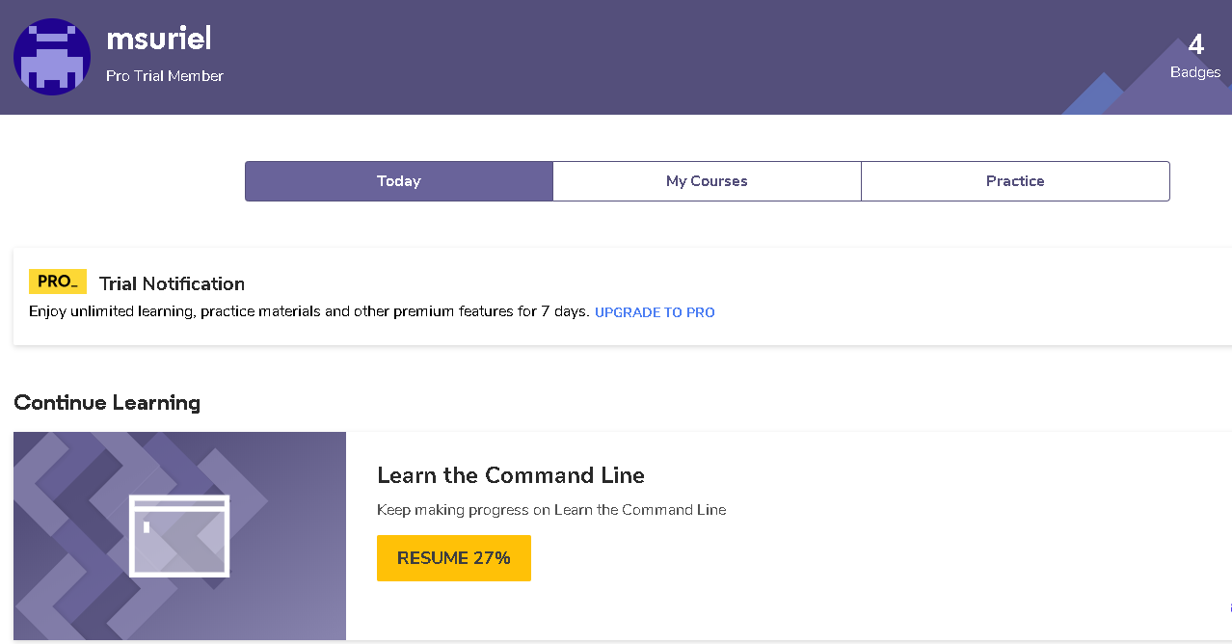

Above you will see the 4 badges for “Learn the Command Line” received for completing the first four lessons.